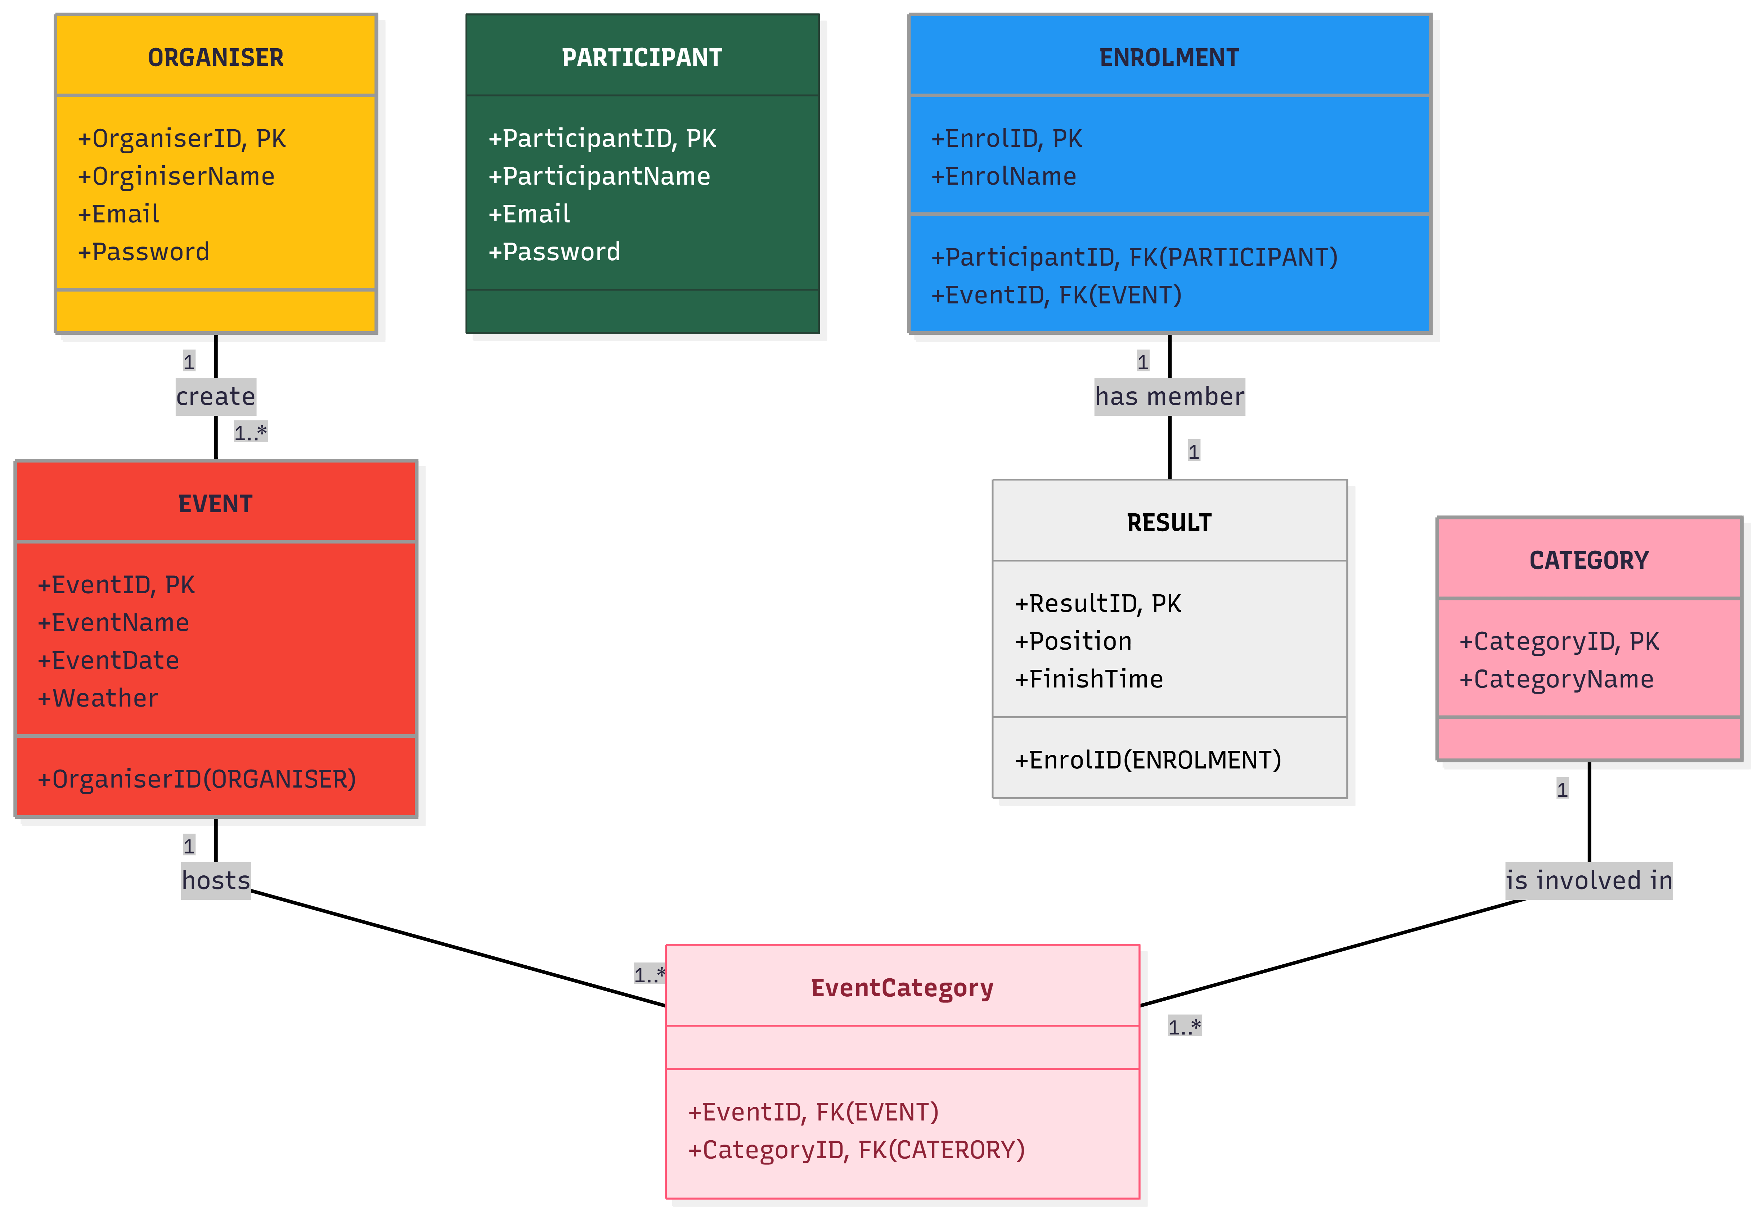

HTPP method | Route | Description | Role Required | Request Body | Expected  Response
POST | /api/auth/register | Register a new participant or event organiser | Public | {name, email, password, role} | 201 Created – User registered
POST | /api/auth/login | Authenticate a user and provide access | Public | {email, password} | 200 OK – Login successful
GET | /api/events | Browse all upcoming events | Public | None | 200 OK – List of events
GET | /api/events/{id} | View detailed information about one event | public | None | 200 OK – Event details
POST | /api/events | Create a new running, walking, or cycling event | Event Organiser | {name, date, location, categoryID, description} | 201 Created – Event created
PUT | /api/events/{id} | Update an existing event | Event Organiser | {name, date, location, categoryID, description} | 200 OK – Event updated
DELETE | /api/event/{id} | Delete an event | Event Organiser | None | 204 OK – Event deleted
GET | /api/categories | Retrieve all event categories | Public | None | 200 OK – Categories returned
POST | /api/categories | Create a new event category | Event Organiser | {name, type} | 201 Created – Category created
POST | /api/event/{id}/  enrolments | Register a participant for an event | Participant | {ParticipantID} | 201 Created – Registration successful
GET | /api/events/{id}/ participant | Cancel a participant’s registration | Event Organiser | None | 200 OK – Enrolment list
DELETE | /api/events/{id}/ participant/ {participantID} | Cancel a participant’s registration | Participant | None | 204 No Content – Registration cancelled
GET | /api/participant/ {Id}/history | View a participant’s personal performance history | Participant | None | 200 OK – Performance history returned
POST | /api/results | Add a participant’s race result | Event Organiser | {enrolmentID, eventID, position, finishTime} | 201 Created – Result recorded
GET | /api/events/{id}/  results | View results for a specific event | Public | None | 200 OK – Event results
GET | /api/events/{id}/  weather | Get weather information for an event | Public | None | 200 OK – Weather information
GET | /api/events/{id}/  route | Get route information for an event | Public | None | 200 OK – Route information

RaceDay.sql

